1. Introduction

LessonDownloads

Lesson Introduction

Show TranscriptSummarize Video

Video Transcript

0:00

Nice to see you again.

0:01

This lesson takes a deep dive into Agile frameworks.

0:05

It begins with an introduction to Agile frameworks in

0:07

general and what the benefits are of an Agile framework.

0:11

This includes coverage of the shared characteristics of

0:15

Agile frameworks and reasons why adopting an Agile framework makes sense.

0:19

We then look at Scrum as a framework and how Scrum

0:23

can be advantageous to when trying to balance priorities.

0:27

Once you get familiar with Scrum,

0:29

you will be able to deliver value with

0:31

flexibility and patience in a collaborative manner.

0:34

This lesson then goes into Kanban as a framework and its

0:38

unique advantage in managing flow and work in progress or WIP.

0:42

Finally, a thorough discussion on XP and its advantages will

0:46

follow, with an appreciation for its best practices around technical excellence.

0:51

By the end of this lesson,

0:53

you will be able to identify the advantages of using a framework,

0:58

identify the specific and shared characteristics of Scrum,

1:02

Kanban and the XP frameworks.

1:05

You will also be able to determine which frameworks are appropriate for a given project,

1:10

identify the core team roles,

1:12

and assign team members to each role,

1:15

as well as implement best practices for each framework,

1:18

including ceremonies and artifacts.

1:21

Let's get going!

What We Will Cover In This Lesson

Nice to see you again. This lesson will focus on Agile Frameworks, with the topic being covered as follows:

* Introduction to Agile Frameworks in general and what the advantages are of using a framework.
* The Scrum Framework and its unique characteristics as a valuable Framework.
* The more lightweight Kanban Framework and its unique advantage in managing flow and WIP
* The XP Framework and its advantages, with an appreciation for its more stringent best practices.

By the End of the Lesson You Will Be Able To...

* Identify the advantages of using a framework
* Identify the specific and shared characteristics of Scrum, Kanban, and XP frameworks
* Determine which frameworks are appropriate for a given project
* Identify the core team roles assign team members to each role
* Implement best practices for each framework, including ceremonies and artifacts

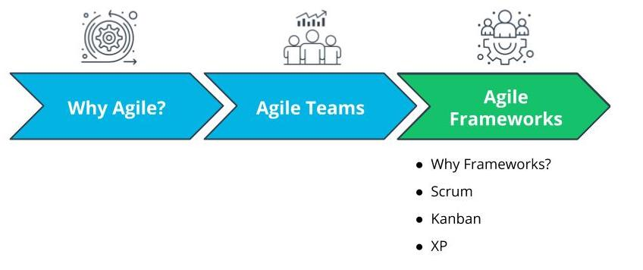

What We Will Cover In This Lesson

# Introduction

LessonDownloads

## Lesson Introduction

Show TranscriptSummarize Video

Video Transcript

0:00

Nice to see you again.

0:01

This lesson takes a deep dive into Agile frameworks.

0:05

It begins with an introduction to Agile frameworks in

0:07

general and what the benefits are of an Agile framework.

0:11

This includes coverage of the shared characteristics of

0:15

Agile frameworks and reasons why adopting an Agile framework makes sense.

0:19

We then look at Scrum as a framework and how Scrum

0:23

can be advantageous to when trying to balance priorities.

0:27

Once you get familiar with Scrum,

0:29

you will be able to deliver value with

0:31

flexibility and patience in a collaborative manner.

0:34

This lesson then goes into Kanban as a framework and its

0:38

unique advantage in managing flow and work in progress or WIP.

0:42

Finally, a thorough discussion on XP and its advantages will

0:46

follow, with an appreciation for its best practices around technical excellence.

0:51

By the end of this lesson,

0:53

you will be able to identify the advantages of using a framework,

0:58

identify the specific and shared characteristics of Scrum,

1:02

Kanban and the XP frameworks.

1:05

You will also be able to determine which frameworks are appropriate for a given project,

1:10

identify the core team roles,

1:12

and assign team members to each role,

1:15

as well as implement best practices for each framework,

1:18

including ceremonies and artifacts.

1:21

Let's get going!

### What We Will Cover In This Lesson

Nice to see you again. This lesson will focus on Agile Frameworks, with the topic being covered as follows:

* Introduction to Agile Frameworks in general and what the advantages are of using a framework.
* The Scrum Framework and its unique characteristics as a valuable Framework.
* The more lightweight Kanban Framework and its unique advantage in managing flow and WIP
* The XP Framework and its advantages, with an appreciation for its more stringent best practices.

### By the End of the Lesson You Will Be Able To...

* Identify the advantages of using a framework
* Identify the specific and shared characteristics of Scrum, Kanban, and XP frameworks
* Determine which frameworks are appropriate for a given project
* Identify the core team roles assign team members to each role
* Implement best practices for each framework, including ceremonies and artifacts



What We Will Cover In This Lesson

# How Experts Approach Agile Frameworks

LessonDownloads

## Thinking About Agile Frameworks

Show TranscriptSummarize Video

Video Transcript

0:00

Let's look at how seasoned agilists approach agile frameworks.

0:04

As an Agile transformation expert,

0:07

I envision these frameworks as the enablers that

0:11

bring to fruition the good intention of an organization's leaders,

0:15

as well as Agile team members.

0:17

It brings some comfort to everyone involved to follow

0:20

a prominent framework that has been tried and tested in the market.

0:24

So, agilists leverage a framework to deliver on some of the significant promises of agile.

0:30

This includes, as the Agile Manifesto states,

0:34

focusing more on the individuals and interactions.

0:37

The organization must bring to life the theoretical appreciation that

0:43

the most significant impact on the success of

0:45

an Agile team are the skilled team members themselves.

0:49

All Agile frameworks emphasize that the ultimate determining factor for

0:54

success of a product are the resources on the Agile Product Delivery team.

1:00

So how do we do this practically?

1:02

We have to recruit and retain the right skilled resources,

1:07

and cultivate a collaborative and value-driven environment

1:11

that elevates the human spirit,

1:13

to bring out the best in each resource for the collective benefit of all.

1:18

While agilists look at a proven track record of accomplishments when recruiting,

1:23

they also look at the right team-oriented mindset

1:27

and willingness to adapt to meet the business' emergent needs.

1:32

Such a recruit, who is a flexible and collaborative team player,

1:37

when given the right environment,

1:39

propels an Agile team forward in the right direction.

1:43

As they say, if it's working well, don't over-fix it.

1:47

Leaders have to regularly be reminded that adopting Agile is supposed to improve

1:52

performance and deliver more value

1:55

directed at the product and, ultimately, organizational vision.

2:00

Each of the Agile frameworks allows for some flexibility,

2:04

so it is important to not impose everything Agile

2:08

all at once on a team that's already performing well and delivering value.

2:13

In fact, high-performing teams are quite likely to

2:17

already be engaged in many Agile practices without even realizing it.

2:21

Such high-performing teams can be gradually introduced to additional Agile practices,

2:27

based on a specific Agile framework,

2:30

through retrospectives and other guided continual improvement opportunities.

2:36

The potential of an Agile team only

2:38

grows when they are challenged to find opportunities for improvement.

2:43

The quality of the stories that are brought into the backlog is important.

2:48

Agilists work with product owners to ensure

2:51

the user stories have been sufficiently refined for the agile team to proceed.

2:55

Now, a PO has to be reminded that it is

2:59

not their job to zero in on a specific technical solution.

3:03

That is the Agile team's responsibility.

3:06

A PO who heavily intrudes into solutioning

3:09

will inhibit the Agile team's innovative drive.

3:13

Transforming teams into an Agile mindset is hard enough.

3:17

A lack of respect for the backlog's priorities and

3:21

realistic estimates can drive the Agile team and everyone else crazy.

3:26

Agilists focus on ensuring that the agile team does

3:29

not over-commit to what can be accomplished in each iteration,

3:33

especially during the first few iterations.

3:36

A close eye must be kept on the product backlog board,

3:40

with the help of a regularly updated work tracking system such as JIRA, ADO, or Rally.

3:47

At the end of the day,

3:49

implementing a specific Agile framework is a fine balancing act.

3:54

Organizations must be willing to adapt,

3:57

based on each organization's unique culture and context.

4:00

Experts have to regularly remind both leaders and the Agile team

4:05

to remember that there is no one way to execute Agile practices in an organization.

4:10

Agile principles and practices are,

4:13

by their very nature,

4:15

to be adapted as needed.

### Agile Frameworks are Enablers that Bring to Fruition the Value of Agile

This includes:

* Focusing more on the individuals and interactions; ultimate determining factor for the success of a product are the resources on the Agile product delivery team.
* Do not force Agile unnecessarily; Teams that are already performing well can be gradually introduced to additional Agile practices based on a specific Agile Framework.
* Refined user stories are important; Agilists work with Product Owners to ensure the user stories have been sufficiently refined for the Agile Team to proceed.
* Respect the backlog; Agilists focus on ensuring the Agile Team does not over-commit to what can be accomplished in each iteration, especially during the first few iterations.

### Implementing a Specific Agile Framework is a Fine Balancing Act

* Must adapt based on each organization’s unique culture and context.
* Experts have to regularly remind both leaders and the Agile Team to remember that there is no one way to execute Agile practices in an organization.
* Agile principles and practices are by their very nature to be adapted as needed.

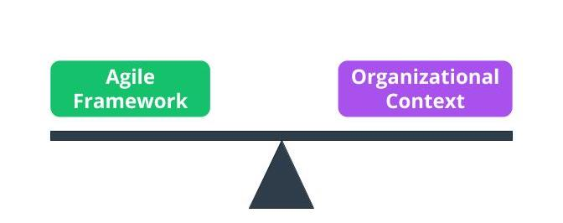

Framework “Balanced” with Organizational Context

### Quiz Question

TRUE or FALSE

Agile is designed in a way so all parties can provide feedback as the software is developed in an efficient and effective manner.



TRUE



FALSE

Submit

### Reflect

Explain the precautions associated with tailoring Agile Frameworks to an organization’s own circumstances.

Submit

### Additional Resources

* [**Advanced Topics in Agile Planning(opens in a new tab)**](https://www.mountaingoatsoftware.com/presentations/advanced-topics-in-agile-planning): In this presentation, Mike Cohn walks through Advanced Agile Planning.

# Agile Frameworks

LessonDownloads

## What Are Agile Frameworks?

Show TranscriptSummarize Video

Video Transcript

0:00

Agile has come to be an umbrella term for

0:03

a variety of frameworks that align with the Agile Manifesto.

0:07

The Agile Manifesto drives the Agile mindset's shared

0:12

principles that are universal and encouraged across all the frameworks.

0:18

Under the Agile umbrella,

0:20

at the heart of every Agile product development in a complex environment is that

0:25

one invincible idea that someone in the business thinks is a sure win for the market.

0:31

However, history has taught us that a product and its features need to be adjusted along

0:36

the way to genuinely become

0:38

that great invincible solution that the market will fall in love with.

0:42

The dot-com bubble around the turn of the century taught us

0:45

the harsh lesson that if we're not willing

0:47

to be adaptable based on the pulse of the market,

0:50

our products can very quickly become irrelevant to end users.

0:54

Every Agile team's goal is to deliver value-driven functionality with built-in quality.

0:59

There's the inspirational desire to deliver upon

1:02

that great idea that customers love and to do it quick.

1:06

So how should Agile teams deliver both amazing product features that delight customers,

1:12

as well as do it fast?

1:14

One way to make this happen is to quickly change course when it is

1:18

realized that a product feature is heading down the wrong path.

1:22

That is what the Agile world refers to as failing fast and learning.

1:26

With a limited amount of resources,

1:29

the longer it takes for an organization to

1:31

realize that a particular idea is not a true winner,

1:34

the more resources are wasted.

1:37

The significant advantage of failing fast is that if

1:41

a customer does not provide positive feedback for functionality being built,

1:45

the Agile team can quickly readjust

1:47

their priorities and focus on other more important items.

1:51

Enlightened and directed trial and error is what

1:54

the growth mindset promotes when it comes to fail fast and learn.

1:58

An absolutely key driver behind anything Agile is to deliver value.

2:04

Each Agile framework, which we will be discussing,

2:07

is driven by the goal of delivering maximum business value.

2:11

It is aligned with the organization's vision.

2:15

A continual improvement process,

2:18

also often called a continuous improvement process,

2:22

is an ongoing effort to challenge everyone involved

2:26

to improve the product features or processes being used to deliver the product.

2:30

Agile promotes incremental improvement to minimize resistance from all who are involved.

2:37

Ultimately, flexibility is one of the foundations of any Agile framework.

2:42

Identifying opportunities for flexibility in

2:46

the processes and the adaptive planning that Agile frameworks

2:49

promote allows the Agile team to adapt to changes

2:53

and still have the strong capability to deliver a valuable product.

2:57

Agile frameworks promote trust and respect because

3:01

such trust and respect motivates Agile teams.

3:05

and all the frameworks state that Agile teams strive to deliver what they have committed to.

3:11

In fact, trust and respect are really the foundation for all Agile frameworks.

3:18

All Agile frameworks encourage Agile teams to cultivate mastery.

3:23

In Agile teams, time is put aside for learning and growth.

3:28

This allows Agile team members to sharpen their skills.

3:31

This built-in structure to hone their skills,

3:35

further motivates the Agile team and additional valuable results are produced.

3:40

This mindset of continual improvement is built in alongside built-in quality.

3:47

Under the Agile umbrella,

3:49

there are a large number of ever-growing frameworks. Some are listed here.

3:54

They include the ones identified here, plus many others.

### Agile is an Umbrella Term for a Variety of Frameworks that Align with The Agile Manifesto

Every Agile team's goal is to deliver value-driven functionality with built-in quality and to do it quickly. This is where **Fail Fast and Learn** is priceless. Agile teams who wish to deliver both amazing product features that delight customers, as well as do it fast, must learn to quickly change course when it is realized that a product feature is heading down the wrong path.

### The Agile Umbrella

The Agile Umbrella has some key characteristics:

* **Deliver Value**: An absolutely key driver behind anything Agile is to deliver value.
* **Continual Improvement**: Agile promotes incremental improvement to minimize resistance from all who are involved.
* **Flexibility**: Flexibility is one of the foundations of any Agile Framework.
* **Trust and Respect**: Agile Frameworks promote trust and respect because such trust and respect motivate Agile teams.
* **Cultivate Mastery**: This built-in structure for Agile team members to hone their skills further motivates the Agile team.

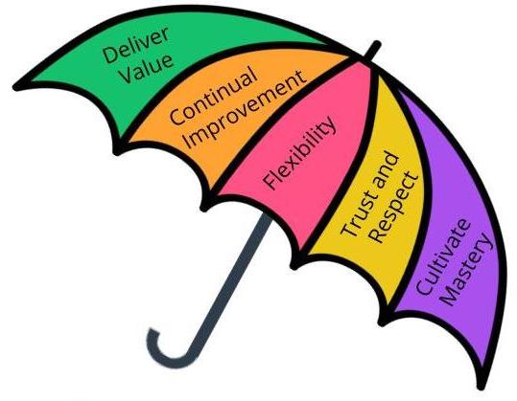

The Agile Umbrella

### New Terms

* **Agile Umbrella**: A term that refers to the various Agile Frameworks that follow the Agile Manifesto's values and principles

### Additional Resources

* [**Five Powerful Enterprise Agile Frameworks(opens in a new tab)**](https://dzone.com/articles/five-powerful-enterprise-agile-frameworks-1): In this blog, Prabhu Arumugham walks through five Enterprise Agile frameworks that act as process 'blueprints' providing a set of Agile practices, organizational structure, roles, and other recommendations.
* 6. Exercise: Agile Frameworks
* LessonDownloads
* The Benefits of Agile Frameworks for SocialKare.gov
* How would SocialKare.gov benefit from using an Agile Framework? Review the [**SocialKare.gov Case Study(opens in a new tab)**](https://video.udacity-data.com/topher/2020/September/5f5f6bc7_agnd-c1-foundations-of-agile-socialkare.gov-case-study/agnd-c1-foundations-of-agile-socialkare.gov-case-study.pdf) and identify at least three benefits of using an Agile Framework at SocialKare.gov. Explain how those benefits will help SocialKare.gov be more effective in reaching its goals.
* 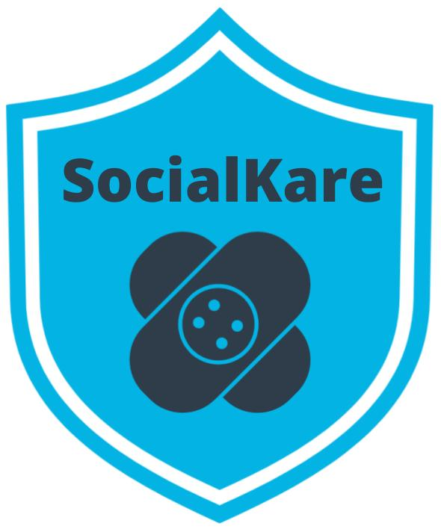

# 7. Solution: Agile Frameworks

LessonDownloads

## My Solution

Show TranscriptSummarize Video

Video Transcript

0:00

In this exercise, you are asked to identify three benefits of using

0:05

an Agile framework and explain how

0:08

those benefits will help SocialKare.gov achieve its goals.

0:12

Let's look at my response.

0:14

Each Agile framework has grown out of the real life experiences of

0:18

professionals who did not want to be

0:21

limited by the challenges of the traditional waterfall approach.

0:25

So SocialKare.gov would benefit from the years of experience that

0:30

a proven framework has been built upon and further

0:33

refined over time at many organizations globally.

0:37

Such real life experiences will help

0:40

SocialKare.gov learn from the mistakes made by other Agile teams,

0:44

such as launching a feature without getting proper user input.

0:48

By using a proven framework,

0:51

there's a higher level of predictability for the organization.

0:55

For example, SocialKare.gov leadership and Agile team

0:59

both will benefit from defined ceremonies and defined roles for

1:04

the Agile team that make it easier to go through an Agile transformation

1:08

knowing that this has been tried and has worked for other organizations.

1:14

By adopting a proven Agile framework and its associated practices,

1:19

organizations benefit from higher quality product delivery.

1:23

SocialKare.gov will be able to deliver solutions in a timely manner with

1:29

a significantly higher level of end user satisfaction

1:33

because Agile Frameworks have quality built into each product deliverable iteration.

1:39

This prevents expensive delays due to

1:42

defects and rework at the end of the development cycle.

1:46

Another key benefit of any Agile framework is that it allows for customizing,

1:51

adapting the framework to better align with the organization.

1:55

Much like any organization,

1:57

the unique nature of SocialKare.gov product development environment will tend to lead to

2:02

some tailoring to better fit SocialKare.gov specific processes.

2:08

This refinement is best done once SocialKare.gov has tried out

2:13

an Agile Framework in its original form for awhile and learn from it.

2:18

That was my solution.

2:20

How does your answer differ from mine?

### Identify Three Benefits of Using an Agile Framework

SocialKare.gov will benefit from:

* Years of experience that a proven Agile Framework has been built upon and further refined over time at many organizations globally.
* By using a proven framework, there’s a higher level of predictability for SocialKare.gov.
* SocialKare.gov will benefit from higher quality product delivery.
* An Agile Framework allows for customizing and adapting the Framework to better align with the organization.

# 8. Scrum

LessonDownloads

## What Is Scrum?

Show TranscriptSummarize Video

Video Transcript

0:00

Let us look at the important characteristics of the Scrum framework.

0:03

Scrum is by far the most common Agile framework in use across industries globally.

0:10

In Scrum, the Agile team creatively manages the work with a focus on delivering

0:18

complex, adaptive product features in an age when

0:21

customers expect rapid responses based on emerging market needs.

0:27

The features are delivered in iterations, known as sprints,

0:31

without compromising on quality.

0:33

In fact, quality is built into the Scrum framework.

0:37

Scrum prescribes a model in which a self-directed and self-organized Agile team,

0:44

plans their work themselves in a decentralized manner.

0:49

The Agile team conducts daily stand-ups

0:52

in which they provide updates to each other every day.

0:55

They deliver in short sprints and they identify

0:58

opportunities for improvement through retrospectives at the end of each sprint.

1:03

The Scrum framework introduces specific roles with recommended responsibilities.

1:09

Scrum also introduces ceremonies with a recommended agenda, duration, and frequency.

1:16

Several of the Agile artifacts are regularly used in Scrum.

1:20

We will look at them in a few minutes.

1:23

Now, let us look at Scrum's pillars and values.

1:27

Scrum is based on three pillars and five fundamental values.

1:33

Transparency in Scrum refers to explicitly giving visibility to all involved,

1:39

such as the business users,

1:41

the organization's leadership, the product owner,

1:44

as well as the Agile team itself.

1:47

In order for transparency to work effectively,

1:50

Scrum recommends that significant aspects of the product

1:53

delivery process should be defined by a common standard.

1:57

This will help everyone in having a consistent understanding of what is being observed.

2:02

Such transparency builds trust and openness,

2:06

both within the Agile team as well as with those stakeholders outside the Agile team.

2:11

Inspection involves the business users or

2:16

their representatives reviewing the Agile team's progress

2:19

towards the defined goals and objectives.

2:22

This needs to be done with some frequency,

2:25

with the recommendation being that such an inspection

2:27

should take place at least once per sprint,

2:30

but not so frequently that it slows the Agile team's progress.

2:34

This helps with quickly identifying any unwanted variances from the defined sprint goals.

2:41

With adaptation, Scrum encourages Agile teams to

2:45

adjust and adapt based on opportunities for improvement

2:49

that are identified either by the Agile team

2:52

themselves or through feedback from others outside the Agile team.

2:57

Adjustments could include process improvements if it appears that

3:01

the existing process will negatively impact the final product deliverables.

3:05

Such adjustments should be proactively

3:09

dealt with to reduce further divergence from the goals.

### Scrum Framework

Scrum is by far the most common Agile Framework.

* The features are delivered in iterations known as Sprints.
* The Team conducts Daily Stand-Ups in which they provide updates to each other.
* Retrospectives are conducted to identify opportunities for improvement at the end of each Sprint.
* Specific roles, as well as certain Ceremonies, are recommended in the Scrum Framework.

### Scrum Pillars

* **Transparency** - Transparency builds trust and openness both within the Agile Team, as well as with those stakeholders outside the Agile Team.
* **Inspection** - Inspection involves the business users reviewing the Agile Team’s progress towards the defined goals.
* **Adaptation** - Agile Teams adjust and adapt based on opportunities for improvement that are identified either by the Agile Team themselves or through feedback from others outside the team.

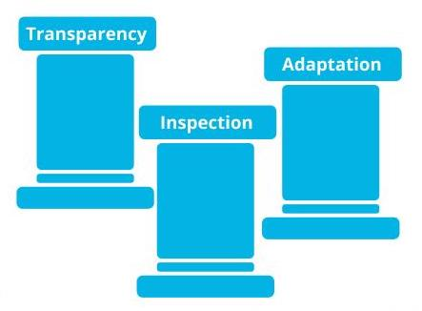

Scrum Pillars: Transparency, Inspection and Adaptation

## Scrum Values

Show TranscriptSummarize Video

Video Transcript

0:00

Now, let's look at the Scrum values.

0:03

There are five Scrum values.

0:06

They are: focus, courage,

0:10

openness, commitment, and respect.

0:15

Let's discuss each one of these Scrum values.

0:18

Delivering product features and results is a collaborative effort in Scrum,

0:24

that requires everyone to focus on

0:28

the work to be completed in order to deliver the sprint goals.

0:32

Focus, much like all the Scrum values, is derived in Scrum from the Agile Manifesto.

0:39

In Scrum, members of the Agile team need to have courage to

0:44

do what is right to ensure that the sprint goals are met.

0:49

This may include having the courage to dig deep into

0:53

challenging problems being encountered and work through them.

0:58

Openness is key to Agile team performance.

1:02

The Scrum team and its stakeholders agree to a culture of openness.

1:07

This ensures everyone will be comfortable to openly discuss all the work underway,

1:13

as well as any obstacles and challenges that may arise.

1:17

Commitments build trust within the Agile team members

1:22

and perhaps more importantly with the business users and leaders of the organization.

1:27

Scrum encourages the Agile team to have a reasonable and good faith approach

1:32

to negotiating the sprint goals and

1:34

sincerely strive to attain the committed sprint goals.

1:37

Essentially, every Agile team member in Scrum,

1:41

personally commits to accomplishing the goals.

1:45

Respect is a key foundational element in Scrum for a high-achieving Agile team.

1:51

The Scrum framework states that respect elevates

1:55

the Agile team members' participation by including them

1:58

in ceremonies and all key planning components.

2:02

This increases the Agile team's motivation.

2:06

So, does Scrum make sense with all projects?

2:10

The answer is a clear no.

2:13

We discussed the Stacey diagram in an earlier lesson.

2:16

As the Stacey diagram shows,

2:19

an Agile framework like Scrum works best with

2:22

complex and complicated projects and products.

2:26

When there is near certainty on both the requirements and process upfront,

2:31

then there may not be as much value in utilizing Agile principles.

2:36

Scrum is also not a magical solution for chaos.

2:40

That is, Scrum cannot miraculously bring value to an environment,

2:45

where there is no vision and no clear roadmap.

2:48

Again, Scrum also does not really make a lot of sense for

2:52

simple, predictable projects and products where the need

2:56

for iterative learning and adapting is of no value.

### 5 Scrum Values

* **Focus** - Everyone in the Team focuses on the work to be completed in order to deliver the Sprint goals.
* **Courage** - Members of the Team need to have the courage to do what is right to ensure the Sprint goals are met.
* **Openness** - The Team and its stakeholders agree to a culture of openness.
* **Commitment** - Commitments build trust within the Agile Team members, as well as with the business users and leaders.
* **Respect** - Respect is a key in Scrum for a high-achieving Agile Team.

### When Scrum Does Not Make Sense

As shown in the Stacey diagram, an Agile Framework like Scrum works best with complex and complicated projects and products. There may not be much value in utilizing Agile principles

* when there is a near certainty in both the requirements and process upfront.
* when there is chaos. Scrum cannot bring value to an environment where there is no vision or clear roadmap.
* when the project is simple and predictable and the need for iterative learning and adapting is of no value.

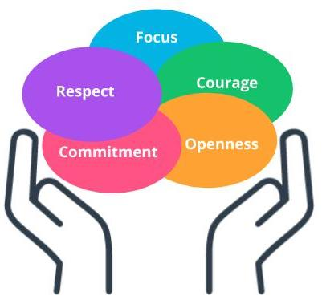

Scrum Values

### New Terms

* **Scrum**: Scrum is one of the most popular Agile frameworks for developing complex products, with an emphasis on value delivery
* **Scrum Pillars**: Transparency, Inspection, Adaptation
* **Scrum Values**: Focus, Courage, Openness, Commitment, Respect
* **Sprint**: A Sprint in Scrum is a repeatable fixed time-box iteration during which a minimum shippable product is delivered

### Additional Resources

* [**Scrum Guide(opens in a new tab)**](https://www.scrum.org/resources/scrum-guide?gclid=Cj0KCQjwhIP6BRCMARIsALu9LfnAyjv8_sgGwYw7igmvP6xYi0kb9-lwQv0M6FWeO5I0O2ZNSj9Uv_QaAqOKEALw_wcB): The Scrum Guide provides complete details on the Scrum Framework.
* Kenneth Rubin. ***Essential Scrum: A Practical Guide to the Most Popular Agile Process: A Practical Guide To The Most Popular Agile Process***. Pearson, 2013.  
  This book is a comprehensive guide to the Scrum framework.

# 9. Scrum Ceremonies and Roles

LessonDownloads

## Scrum Ceremonies, Project Vision, Daily Stand Up, and Sprint Planning

Show TranscriptSummarize Video

Video Transcript

0:00

In order to minimize wasting time in unnecessary meetings and group discussions,

0:05

the Scrum framework recommends focused meetings with a specific purpose.

0:11

These meetings are typically called ceremonies or events in Scrum.

0:15

The recommended Scrum ceremonies are:

0:18

Project Vision, the Daily Stand Up,

0:21

Sprint Planning, the Sprint Review or demo,

0:25

the Sprint Retrospective, Release Planning.

0:29

Let's review each of these ceremonies.

0:31

The Project Vision ceremony in Scrum is a meeting where

0:36

the business leaders identify the business need

0:38

the project's product deliverable is intended to achieve.

0:42

The agenda is to discuss the project goals.

0:45

It is also extremely important to have

0:48

strong leadership support and sponsorship from the top.

0:51

A sponsor is identified at this ceremony.

0:54

The vision for this project's product is outlined by the business leaders,

0:59

along with clearly outlined success criteria.

1:03

High-level assumptions, constraints, and risks are also identified here

1:07

before the project is initiated to help set realistic expectations.

1:13

The Project Vision ceremony only needs to occur once per project,

1:17

It is scheduled right before the project launch.

1:21

Scrum recommends the ceremony to be timeboxed to one hour.

1:25

The most important outcome of this ceremony is that

1:29

the business will craft a desired future state statement,

1:34

This statement clarifies the business value of developing a product.

1:39

Such a clearly envisioned product lays out

1:43

a high-level path to help accomplish the requested objectives.

1:48

The purpose of the Daily Stand-Up,

1:50

also known as the Daily Scrum in some organizations,

1:53

is to synchronize activities and create a short-term plan for the next 24 hours.

1:59

The goal is to gaze

2:00

the Agile Team's progress towards accomplishing the committed Sprint Goals.

2:04

It is a 15 minutes timeboxed ceremony that is held every day.

2:10

The Scrum framework recommends the Daily Stand-Up to be scheduled at the same time daily,

2:16

preferably in the morning.

2:18

If the team is co-located,

2:20

the ceremony should be held in the same location as well for consistency.

2:24

The conversation in this ceremony is strictly contained to only address

2:29

the following questions by each Agile Team member very briefly: First,

2:35

what did I do since the last time we met?

2:38

Second, what do I plan to accomplish today?

2:42

Third, what impediments am I encountering?

2:46

Again, each Agile Team member briefly answers these questions,

2:51

not their manager or other superior.

2:54

Scrum builds a self-directed Agile team structure.

2:58

This cultivates transparency across the product development journey.

3:02

Now, it is the responsibility of the Scrum Master to ensure that

3:06

the conversation remains focused to just addressing these three questions.

3:12

This is not an occasion for deep-dive problem-solving,

3:16

Any further discussion on root cause analysis or technical troubleshooting

3:22

should take place outside this ceremony so other Agile team members can get back to work.

3:28

The Sprint Planning ceremony is where

3:31

the Agile team self-organizes and plans out the work to be performed in the sprint.

3:37

This is the work that has been prioritized by the product owner.

3:41

Again, everyone on the Agile Team collaborates in Sprint Planning.

3:46

The Scrum framework recommends that Sprint Planning should be

3:49

time-boxed to not more than eight hours for a one-month sprint.

3:54

Many organizations I have worked with have two-week Sprints,

3:58

in such a case,

4:00

Sprint Planning should be even shorter.

4:02

Now, Sprint Planning does not all have to occur in one sitting,

4:06

in fact, it is common to have more than one Sprint Planning session during a Sprint.

4:12

The Scrum Master ensures that the timebox is not exceeded in Sprint Planning.

4:18

The Agile Team works with the PO and Scrum Master to address

4:22

the following three questions: What are we committed to deliver in the upcoming Sprint?

4:27

Again, this is primarily driven by the PO.

4:31

How will we complete the work required to achieve this commitment?

4:35

What are the respective estimates for each user story and associated tasks?

4:41

The PO guides the Agile team on what needs to be done by prioritizing the backlog items.

4:47

the Agile Team then takes

4:49

the prioritized backlog items and collaboratively deciphers how to carry out the work.

### Scrum Ceremonies

Scrum Ceremonies are focused meetings with a specific purpose. The recommended Scrum Ceremonies are:

* Project Vision
* Daily Stand Up
* Sprint Planning
* Sprint Review/Demo
* Sprint Retrospective
* Release Planning

We will discuss each of these Ceremonies.

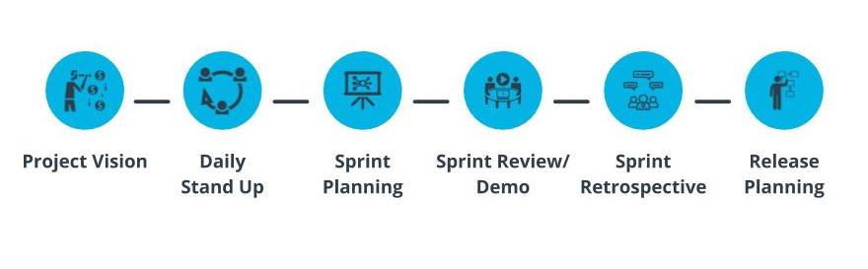

Scrum Ceremonies

### Project Vision, Daily Stand Up, and Sprint Planning

### Project Vision

* Project Vision Ceremony is where the business leaders identify the business need the project’s product deliverable is intended to achieve.
* Agenda - Discuss the project goals, identify the sponsor, and outline the project vision, success criteria, assumptions, constraints, and risks.
* Project Vision occurs ***once per project*** and is scheduled before the project launch.
* Scrum recommends this ceremony be time-boxed to 1 hour.
* Outcome - Business leaders create a desired future state statement.

### Daily Stand Up or Scrum

* The Daily Stand Up is used to synchronize activities and create a short-term plan for the next 24 hours.
* It is time-boxed to 15 minutes and is ***held every day***, throughout the whole scrum ceremonies, ideally at the same time daily.
* Three questions are addressed by each Team member briefly:
  1. What did I do since the last time we met?
  2. What do I plan to accomplish today?
  3. What impediments am I encountering?
* This is a very valuable Ceremony in which all Team members get an opportunity to report issues they are facing; cultivates transparency across the product development journey.

### Sprint Planning

* The Team self-organizes and plans out the work to be performed in the Sprint.
* The work is prioritized by the Product Owner.
* Time-boxed to not more than eight hours for a one-month Sprint.
* Agile Team works with the PO and Scrum Master to address the following three questions:
  1. What are we committing to deliver in the upcoming Sprint?
  2. How will we complete the work required to achieve this commitment?
  3. What are the respective estimates for each user story and associated tasks?
* The Agile Team takes the prioritized backlog items and collaborates on how to carry out the work.

Notes: the Daily Stand Up or Scrum is held daily, including the time between Sprint Planning and Sprint Review.

## Sprint Review/Demo, Retrospective, and Release Planning

Show TranscriptSummarize Video

Video Transcript

0:00

The purpose of the Sprint Review or Demo is to

0:03

generate feedback and nurture collaboration.

0:06

The Agile team demonstrates

0:09

a Sprint's incremental work to

0:11

the product owner, as well as to other business representatives.

0:15

The Agile team and the PO transparently discuss accomplishments,

0:22

as well as any remaining items in the product backlog.

0:26

The PO, on behalf of the business,

0:30

determines if the sprint deliverables are acceptable

0:33

based on the acceptance criteria and definition of done.

0:36

Marketplace changes are taken into account to

0:40

assess if the product backlog needs to be reprioritized,

0:44

and the PO, along with the Agile team,

0:47

mutually make any adjustments that need to be made to optimize value.

0:52

The Sprint Review or Demo ceremony only occurs

0:56

once per Sprint and is scheduled at the end of each Sprint.

1:00

For a one-month Sprint,

1:02

the Scrum Framework recommends a timebox of four hours for the Sprint demo.

1:06

For two-week sprints,

1:08

which is more common,

1:09

sprint reviews are prorated to two hours.

1:12

The sprint retrospective ceremony is a significant inspect and adapt session.

1:18

The unique flavor here is that the Agile team self-inspects its performance during

1:24

the Sprint and identifies practical opportunities for improvement for subsequent Sprints.

1:30

Retrospectives are primarily for the Agile team.

1:35

Retrospectives are held after the Sprint Review.

1:38

Scrum recommends that for a one-month Sprint,

1:41

Retrospectives should be timeboxed to three hours.

1:45

In reality, Retrospectives are usually shorter.

1:49

The Agile Team takes into account the PO's feedback from the Scrum Review ceremony.

1:55

The Scrum Master facilitates this discussion,

1:57

and the Agile Team will look for all opportunities for

2:00

improvement in terms of process, tools, and people.

2:05

In the meeting, the Agile Team creates a plan for carrying out improvements.

2:11

The Agile Team also discusses what went well,

2:14

as well as what to continue to do that is working

2:17

very well for the Agile Team in terms of delivering value.

2:21

While the Scrum framework encourages that the Agile team partake

2:25

improvements at any time during the product delivery lifecycle,

2:29

the Sprint Retrospective ceremony is

2:32

a structured opportunity to have a targeted inspection and adaptation session.

2:38

In the release planning ceremony,

2:40

the Agile Team develops a release plan that defines when

2:45

a collection of functionality will be delivered to the customer base.

2:50

This is done with direct input from the business units or

2:54

client-side users since they decide when to release product features to market.

2:59

The release planning ceremony's agenda is to first

3:03

discuss critical dates and milestones,

3:06

coordinate with dependent departments and systems,

3:09

and balance business value versus quality.

3:12

The release planning ceremony only occurs when there is a release.

3:17

Scrum recommends the ceremony to be timeboxed to 20 minutes.

### Sprint Review/Demo, Retrospective, and Release Planning

### Sprint Review/Demo

* The purpose is to generate feedback and nurture collaboration.
* The Team demonstrates the Sprint’s incremental work to the PO and other business representatives.
* The Team and PO transparently discuss accomplishments, as well as opportunities for improvement.
* The PO determines if the Sprint deliverables are acceptable based on the Acceptance Criteria and Definition of Done.
* Occurs once at the end of each Sprint with a time-box of 4 hours for a one-month Sprint.

### Sprint Retrospective

* The Team self-inspects its performance during the Sprint and identifies practical opportunities for improvement for subsequent Sprints.
* Retrospectives are held after the Sprint Review; time-boxed to 3 hours for a one-month Sprint.
* The Team also discusses what went well, as well as what to continue to doing that is working very well for the Agile Team in terms of delivering value.

### Release Planning

* The Team develops a Release Plan that defines when a collection of functionality will be delivered to the customer base.
* The agenda is to discuss critical dates and milestones, coordinate with dependent departments and systems, and balance business value vs quality.
* Only occurs when there is a Release; time-boxed to 20 minutes.

## Scrum Roles and Artifacts

Show TranscriptSummarize Video

Video Transcript

0:00

Now let us look at the three core roles in Scrum.

0:03

Much like the various agile frameworks,

0:06

there are three core roles in the Scrum framework as well.

0:09

The first is the Product Owner or PO,

0:12

who is seen as the voice of the customer.

0:14

The next key role is that of the Scrum Master,

0:17

who is the key facilitator.

0:19

And then we have the Agile Team,

0:22

who are also known as the Scrum Team sometimes.

0:25

Let us look at all three of these important roles.

0:29

A PO is a critical role in Scrum since the PO is responsible for working with

0:35

both the Agile Team as well as the business to

0:38

maximize the value of the product deliverables being worked on.

0:42

The product owner is primarily responsible for

0:45

prioritizing and managing the product backlog.

0:49

A successful Agile Team in Scrum consists of

0:52

cross-functional, skilled professionals with T-shaped skills.

0:57

Agile teams are self-directed and self-organized.

1:01

Management, along with the Scrum Master and PO,

1:05

empower the Agile Team to organize and manage

1:08

their own work once the PO has prioritized the business needs.

1:12

This symbiotic relationship between the Scrum Master, PO,

1:17

and agile team optimizes the agile teams overall

1:21

confidence and ability to deliver valuable product features in each iteration.

1:26

The agile team members are the ones who accomplish the actual work of

1:31

completing and delivering a potentially shippable version

1:34

of the product at the end of each iteration.

1:37

The Scrum Master is responsible for ensuring the Agile Team moves

1:40

along at an acceptable pace towards the business objectives.

1:44

The Scrum Master plays an important role in helping the Agile Team towards removing

1:49

any blockages or impediments that may be slowing the Agile Team.

1:54

The Scrum Master typically facilitates the ceremonies as well,

1:58

although the Scrum framework encourages the Agile Team to

2:02

conduct ceremonies on its own if the Scrum Master is away.

2:06

The Scrum Master is a servant leader to the Agile Team as well as the PO.

2:12

The Scrum Master supports the PO in various ways,

2:16

such as keeping the product backlog refined and

2:19

clarifying backlog items to the Agile Team.

2:22

The Scrum Master also serves as a coach to

2:24

the Agile Team in the adoption of Scrum practices.

2:28

Next, let us look at the Scrum Artifacts.

2:32

In the Scrum framework,

2:34

artifacts are used to transparently communicate

2:37

the Agile Team's progress and value being delivered.

2:41

This openness allows for

2:43

constructive feedback since all the key information is available to everyone involved.

2:48

The artifacts are designed to be easily

2:50

understood to ensure everyone is on the same page.

2:54

There are three artifacts recommended in the Scrum Guide.

2:58

They are the Product Increment,

3:00

the Product Backlog, and the Sprint Backlog.

3:04

Let's discuss each of these Scrum artifacts.

3:08

The product increment clarifies what is being

3:11

delivered in each increment at the end of each sprint.

3:15

The PO and Agile Team agree on the Definition of Done,

3:20

that is, the Agile Team commits to what will be done in a sprint,

3:25

with the PO identifying the acceptance criteria.

3:29

The Product Backlog is the prioritized list of work to be delivered by the Agile Team.

3:35

The PO, with consultation from the Agile Team,

3:39

prioritizes the product backlog.

3:42

The backlog items are dynamic and evolving

3:45

based on emergent needs of the business and customer demand.

3:49

The sprint backlog contains

3:51

the prioritized items that the PO has designated for the sprint.

3:56

A portion of the product backlog items that are of

3:59

higher value are included in the sprint backlog by the PO.

4:04

The Agile Team is given a clear sprint goal by the PO.

4:09

Now there are other useful information radiators that are

4:12

commonly used by agile teams to track and share progress.

4:16

The first is the burndown chart.

4:19

The burndown chart communicates clearly if

4:22

the Agile Team is on target with the sprint commitments and deadline.

4:27

It quickly alerts teams about potential bottleneck situations and problems.

4:32

It shows to everyone an Agile Team's success when it delivers upon its commitments.

4:39

Then there's the burnup chart.

4:41

The burnup chart, much like a burndown chart,

4:45

shows how much work has been completed by the Agile Team.

4:48

It clearly shows the total amount of work for a product or sprint.

4:54

The velocity chart displays the amount of value delivered in each sprint.

4:59

This enables the PO and business to predict capacity,

5:03

which is the amount of work the Agile Team can accomplish in future sprints.

### Scrum Roles

Similar to other Agile Frameworks, there are 3 core roles in the Scrum Framework.

* Product Owner, who is the voice of the customer.
* Scrum Master, who is the key facilitator.
* Agile Team, also known as the Scrum Team sometimes.

### Scrum Artifacts

* **Product Increment** clarifies what is being delivered in each increment at the end of each Sprint.
* The **Product Backlog** is the prioritized list of work to be delivered by the Team. The Backlog items are dynamic and evolving based on emergent needs of the business and customer demand.
* The **Sprint Backlog** contains the prioritized items that the PO has designated for the Sprint.

There are other useful information radiators that are commonly used by Agile teams to track and share progress. These information radiators include Burndown Charts, Burnup Charts, and Velocity Charts.

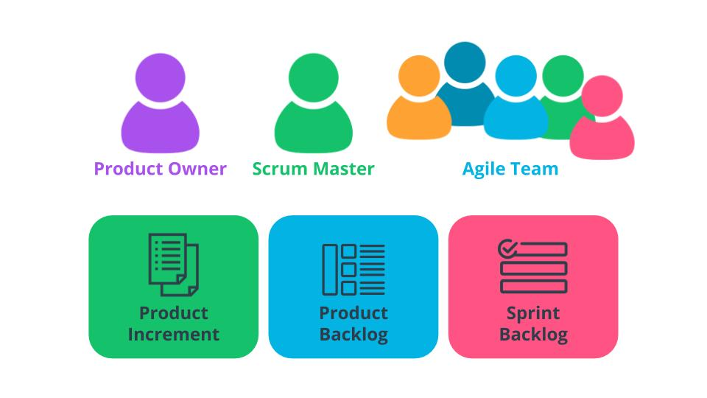

Scrum Role and Artifacts

### New Terms

* **Burndown Chart**: A visual representation of work left to do versus time in an iteration
* **Burnup Chart**: A visual representation of work completed versus time in an iteration
* **Ceremonies**: Meetings that are leveraged to ultimately ensure that everyone associated with the project is in-sync
* **Daily Stand Up**: A ceremony to create a short term plan for the next 24 hours
* **Definition of Done**: The agreed-upon deliverables that must be completed before a user story can be completed
* **Product Backlog**: A prioritized list of Features that an Agile team needs to work on to achieve a specific outcome
* **Product Increment**: The collection of backlog items to be completed during an iteration
* **Project Vision Ceremony**: A ceremony is where the business leaders identify the business need the project’s product deliverable is intended to achieve; the agenda is to discuss the project goals
* **Release Planning Ceremony**: A ceremony where the Agile Team develops a Release Plan that defines when a collection of functionality will be delivered to the customer base
* **Sprint Backlog**: The prioritized items that the PO has designated for the Sprint
* **Sprint Planning Ceremony**: A ceremony is where the Agile Team self-organizes and plans out the work that has been prioritized by the Product Owner
* **Sprint Review/Demo**: A ceremony where the Agile Team demonstrates the Sprint’s incremental work to the Product Owner, as well as possibly other business representatives
* **Velocity Chart**: A chart that shows what the team has delivered in each iteration

### Additional Resources

* [**Formula for Building a Successful Scrum Experience(opens in a new tab)**](https://www.scrumalliance.org/agile-resources/resources-for-your-agile-life/agile-advanced/july-2016/select-repost-formula-for-building-a-successful): This blog post discusses a few pointers to practically help your Scrum team excel and deliver additional value.
* [**Vodafone New Zealand's Agile Transformation Case Study(opens in a new tab)**](https://www.scrum.org/resources/blog/vodafone-new-zealands-agile-transformation-case-study): Edwin Dando walks through Vodafone New Zealand's successful implementation of the Scrum Framework.
* [**Scrum’s Nature: It Is a Tool; It Is Not About Love or Hate(opens in a new tab)**](https://www.scrum.org/resources/blog/scrums-nature-it-tool-it-not-about-love-or-hate): Stefan Wolpers discusses how the Scrum Framework is a tool and must be used properly to reap the anticipated value.

# 11. Exercise: Setting Up Scrum

LessonDownloads

## Set Up the Scrum Framework At SocialKare.gov

Your leaders at SocialKare.gov have advised you that they wish to proceed with using the Scrum Framework.

Review the [**SocialKare.gov Case Study(opens in a new tab)**](https://video.udacity-data.com/topher/2020/September/5f5f6bc7_agnd-c1-foundations-of-agile-socialkare.gov-case-study/agnd-c1-foundations-of-agile-socialkare.gov-case-study.pdf). Explain how you will set up the Scrum Framework for this project team. Include the following:

* Core roles to be filled
* Ceremonies to be conducted
* Schedule and duration of the ceremonies, as well as their purpose and agenda

# 12. Solution: Setting Up Scrum

LessonDownloads

## My Solution

Show TranscriptSummarize Video

Video Transcript

0:00

In this exercise, you are asked to recommend how you would set

0:04

up the Scrum framework for the socialkare.com product delivery team.

0:08

You are asked to include the core roles to be filled,

0:12

the Scrum ceremonies to be conducted,

0:15

and finally, the schedule and duration of the ceremonies as well as their agenda.

0:20

Here are my responses.

0:22

The three core roles in the Scrum framework are the PO,

0:27

Scrum Master, and Agile Team.

0:31

Let's start with the Scrum Master role.

0:34

This role is responsible for facilitating the Agile Team's work,

0:38

obtaining resources for it,

0:40

and protecting it from problems.

0:42

The Scrum Master is a servant leader to the PO and Agile Team.

0:47

The next core role in Scrum is the Product Owner.

0:50

The Product Owner represents the SocialCare.gov

0:54

stakeholders and specifically is known as the voice of the customer.

0:58

This is the one individual who's responsible for

1:01

the prioritized work item list called a product backlog.

1:05

This role at SocialCare.gov will be responsible for prioritizing the backlog,

1:10

share business decisions in a timely manner,

1:13

and is responsible for providing any requirements or

1:16

functionality-related information to the Agile Team in a timely manner.

1:21

The next core role in Scrum is the Agile Team member.

1:26

Agile Team members are responsible for the creation and delivery of a system.

1:31

This role at SocialCare.gov will primarily include developers.

1:35

However, all other Agile Team members will also be included in this category.

1:40

This includes, but is not limited to,

1:43

those who will conduct modeling, programming,

1:47

testing, front-end design, business analysis,

1:52

release activities, and others.

1:56

In the retrospective, there's an opportunity for

1:59

the Scrum Team to inspect itself and create a plan for improvements.

2:04

Team members discuss what went well during the sprint

2:07

as well as opportunities for improvement.

2:10

This occurs once per sprint and is time-boxed to three hours per sprint.

2:16

In the project vision ceremony,

2:18

the business articulates the business need that is intended to

2:21

be achieved, where they discuss the goals,

2:25

who the sponsor is,

2:27

what the vision is,

2:28

they clearly identify the success criteria as well as the assumptions and risks.

2:34

The project vision ceremony occurs once per project and is time-boxed to one hour.

2:40

In release planning, the organization develops a release plan that

2:45

defines when various sets of

2:46

usable functionality or products will be delivered to the customer.

2:50

They discuss critical dates and milestones,

2:54

they coordinate with dependent systems, and balance business value versus quality.

3:00

Release planning occurs once per release and is time-boxed to 20 minutes.

3:06

In the sprint planning ceremony,

3:08

work to be performed in the sprint is planned.

3:11

The agenda includes creating a sprint backlog,

3:15

planning out the tasks,

3:17

and estimating at the task level.

3:19

This can occur a few times per sprint,

3:22

but is time-boxed to a total of eight hours per sprint.

3:26

In the daily stand-ups,

3:28

the Agile Team synchronizes activities and creates a plan for the next 24 hours.

3:33

Each team member answers three questions:

3:37

What did I do since the last time we met?

3:39

What do I plan to accomplish today?

3:41

And what impediments am I encountering?

3:44

The daily stand-up is held daily,

3:46

preferably in the morning,

3:48

and is time-boxed to 15 minutes.

3:51

In the sprint review and demo,

3:53

along with the demo,

3:55

the Agile Team discusses marketplace changes and the backlog with the PO.

4:02

The team presents the completed sprint deliverables to

4:05

the Product Owner based on acceptance criteria and the definition of done.

4:10

This occurs once per sprint and is time-boxed to four hours per sprint.

## Set up the Scrum Framework

You were asked to cover the Core roles, as well as Ceremonies and their details.

### Core Roles in Scrum

* Scrum Master: Servant Leader to the PO and Team.
* Product Owner: PO represents the SocialKare.gov stakeholders and is known as The Voice of the Customer (VOC).
* Agile Team Member: Responsible for the creation and delivery of product solutions.

### Scrum Ceremonies

* Retrospective: An opportunity for the Team to inspect itself and create a plan for improvements; time-boxed to 3 hours once per Sprint.
* Project Vision: Business leaders articulate the business need that is intended to be achieved; time-boxed to 1 hour and occurs once per project.
* Release Planning: A Release Plan is defined as to when various sets of usable functionality or products will be delivered to the customer; time-boxed to 20 minutes per Release.
* Sprint Planning: Work to be performed in the Sprint is planned; can occur a few times per Sprint; time-boxed to a total of 8 hours per Sprint.
* Daily Stand-Ups: The team synchronizes activities and creates a plan for the next 24 hours; Each team member answers 3 questions: What did I do since the last time we met? What do I plan to accomplish today? What impediments am I encountering?; held daily (preferably in the morning); time-boxed to 15 minutes.
* Sprint Review and Demo: Along with Demo, the Team discusses marketplace changes and backlog with PO; the Team presents completed Sprint deliverables to Product Owner; time-boxed to 4 hours once per Sprint.

# 13. Kanban

LessonDownloads

## What is Kanban?

Show TranscriptSummarize Video

Video Transcript

0:00

Let us examine the important characteristics of the Kanban framework.

0:04

Kanban has its origins in lean product development,

0:07

an approach to product development inspired by

0:10

lean manufacturing principles and practices at Toyota.

0:13

Let us first delve into lean product development.

0:17

Lean product development focuses on seven fundamental principles.

0:22

The lean principles of eliminate waste,

0:26

build in quality, create knowledge,

0:30

defer commitment, deliver fast,

0:34

respect people, and optimize the whole,

0:39

set the foundation for Kanban.

0:42

To eliminate waste, it must be recognized and identified.

0:47

So what is waste exactly?

0:49

Waste is anything that does not add value to

0:53

the customer or anything that does not improve the quality,

0:58

and anything that unnecessarily increases

1:01

the amount of time or effort to produce the product.

1:04

Traditional product development focuses on finding defects.

1:08

Lean focuses on good practices to ensure integrity and prevent defects.

1:15

Lean encourages both training and peer-to-peer knowledge transfer to create knowledge.

1:24

In lean, iterative demos to the business users

1:27

allows the team to live through the concept of "do a little,

1:32

show a little, learn a little."

1:35

Collaboration enhances sharing of explicit and tacit knowledge.

1:40

Lean recommends the Agile team wait until the last responsible moment to make a decision.

1:47

The last responsible moment is that point

1:50

where, if the agile team does not make a decision,

1:54

it will either significantly impact the work

1:56

or a decision will be made by others for them.

2:00

The last responsible moment allows for the Agile team to

2:04

remain agile and to have some stretch of innovation.

2:09

Lean encourages the agile team to create product incrementally, where

2:15

the team builds only what is truly needed and avoids unnecessary features.

2:21

Lean recommends to release product earlier to get feedback from the customer sooner.

2:27

The Agile team needs to feel trusted and

2:31

valuable to be able to think and solve problems for themselves.

2:35

They need authority to effect outcomes.

2:39

Product development involves interdependencies with business partners,

2:43

customers, and IT departmental units.

2:47

Lean encourages decreasing barriers to increase efficiencies,

2:52

to decrease the amount of handoffs,

2:55

and to decrease work-in-progress,

2:57

also known as WIP.

2:59

When lean principles are followed,

3:01

customer satisfaction and quality increases while the time to market is reduced.

3:08

Kanban in Japanese refers to a signboard.

3:12

This Kanban board is instrumental in Kanban.

3:16

An approach where the Agile team can visualize the workflow is

3:19

important since it helps in organizing,

3:23

tracking, and optimizing the work.

3:27

Kanban recommends establishing limits to the work the Agile team has in progress.

3:34

Kanban establishes and respects the team's ideal work capacity.

3:39

Limiting WIP helps to smooth the flow of work,

3:44

reduce lead times, improve quality,

3:48

and deliver more frequently.

3:51

By monitoring and measuring the flow of work through each work state,

3:56

issues are identified as soon as possible.

3:59

This helps to minimize lead times and improve delivery predictability.

4:05

Establishing policies that provide the agile team with

4:10

explicit understanding of the processes has tremendous benefits.

4:14

Most importantly, discussions around issues

4:18

can take place in an objective rather than an emotional manner.

4:23

The agile team must own the team's work-related processes

4:29

and work collaboratively to improve the processes being utilized.

4:35

A Kanban board plays a valuable role since it

4:39

articulates the work items in their various stages of the product development journey.

### Kanban Framework

Kanban has its origins in lean product development, an approach to product development inspired by lean manufacturing principles and practices at Toyota.

### Lean Principles

Lean product development focuses on 7 fundamental principles:

* **Eliminate Waste** - Anything that does not add value to the customer.
* **Build in Quality** - Lean focuses on good practices to ensure integrity and prevent defects.
* **Create Knowledge** - Lean encourages both training and peer-to-peer knowledge transfer.
* **Defer Commitment** - Lean recommends the Agile Team wait until the "last responsible moment" to make a decision, which allows for additional time to innovate.
* **Deliver Fast** - Lean encourages the Agile Team to create and deliver the product incrementally.
* **Respect People** - The Team must feel trusted and valuable to think and solve problems for themselves.
* **Optimize the Whole** - Lean encourages decreasing barriers to increase efficiencies by decreasing the amount of hand-offs and reducing WIP.

Lean Principles set the foundation for Kanban.

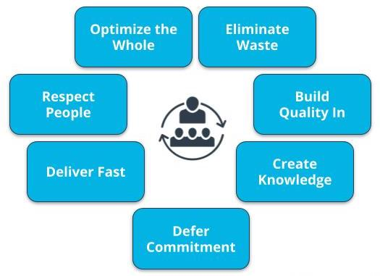

Lean Principles

## Five Principles of Kanban

Kanban is a lightweight Agile Framework with 5 principles:

* **Visualize the Flow** - The Team visualizes the workflow, which helps in organizing, tracking, and optimizing the work.
* **Limit Work in Progress**- Limiting WIP helps to smooth the flow of work, reduce lead times, improve quality and delivery more frequently.
* **Manage Flow** - By Monitoring and measuring the flow of work, issues are identified as soon as possible, which improves delivery predictability.
* **Make Policies Explicit** - Establishing policies provides the Agile Team with explicit understanding of the processes for discussions around issues.
* **Improve Collaboratively** - The Agile Team must own the team’s work related processes and work collaboratively to improve the processes being utilized.

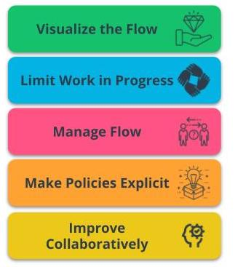

Five Principles of Kanban

A Kanban Board plays a valuable role as an information radiator since it shows the work items in their various stages of the product development journey.

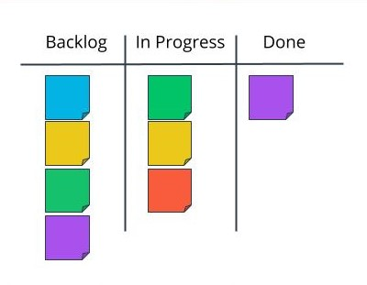

Kanban Board

## Kanban Ceremonies, Core Roles and Artifacts

Show TranscriptSummarize Video

Video Transcript

0:00

In order to minimize wasting time in unnecessary meetings and group discussions,

0:05

the Kanban framework recommends focused meetings with a specific purpose.

0:10

You remember the six Scrum ceremonies, right?

0:14

In Kanban, the ceremonies are simplified.

0:17

There is no sprint planning ceremony,

0:20

and there is no sprint retrospective.

0:23

And the sprint review or demo is just called a review or demo.

0:28

So the four Kanban ceremonies align with four of the Scrum ceremonies.

0:33

The four Kanban ceremonies are virtually the

0:36

same as their counterpart ceremonies in the Scrum framework.

0:40

As you can see here,

0:41

the project vision ceremony in Kanban has virtually the same purpose,

0:46

agenda, timing, as well as expected outcome.

0:50

The same can be said for the daily standup,

0:54

as well as the review or demo,

0:56

and the same also goes for release planning.

1:01

Kanban provides the ability to view in one instance,

1:04

the status of the entire product development journey.

1:07

The Kanban board makes it very easy to visualize what has been completed,

1:12

what is currently in progress,

1:14

and what work items have not commenced yet.

1:17

Since it focuses on the Agile team's workflow and throughput,

1:22

Kanban is seen as a better Agile framework option solution for projects where

1:27

the work is likely to involve a large quantity of relatively small activities.

1:33

Kanban is also suitable for work that may arise on an ad hoc basis.

1:38

Now, let us discuss Kanban roles and artifacts.

1:43

Much like the various Agile frameworks,

1:46

there are three core roles in the Kanban framework as well.

1:50

The first is the Product Owner, or PO,

1:52

who is seen as the voice of the customer.

1:55

The next key role is that of the Facilitator,

1:58

and then we have the Agile team.

2:00

Let's look at all three of these important roles.

2:04

Kanban has a much more flexible approach,

2:07

but two key recommended artifacts are the Kanban board and cumulative flow diagram.

2:14

A Kanban board plays a valuable role since it

2:19

articulates the work items in their various stages of the product development journey.

2:23

With a cumulative flow diagram,

2:26

problem areas are easily detected,

2:29

changes can be made so that work can continue efficiently,

2:33

and a Cumulative Flow Diagram also shows the total amount

2:38

of WIP, or work in process, and how quickly projects are being completed.

### Kanban Ceremonies

You will recall the 6 Scrum Ceremonies. In Kanban:

* The Ceremonies are simplified.
* There is no Sprint Planning Ceremony.
* And there is no Sprint Retrospective.
* Sprint Review/Demo is just called Review Demo.

So, the 4 Kanban ceremonies align with 4 of the Scrum ceremonies.

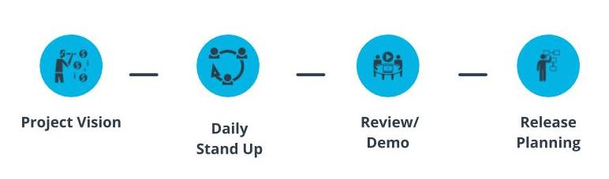

Kanban Ceremonies

### Where Does Kanban Make Sense?

* Since it focuses on the Agile Team’s workflow and throughput, Kanban is seen as a better Agile Framework option solution for projects where the work is likely to involve a large quantity of relatively small activities.
* Kanban is also suitable for work that may arise on an ad-hoc basis.

### Kanban Roles and Artifacts

### Core Roles in Kanban

* **Product Owner** - Seen as the voice of the customer.
* **Facilitator** - Team's Servant Leader.
* **Agile Team** - These are the resources that collaborate and work on the product deliverables.

### Kanban Artifacts

* **Kanban Board** - A Kanban Board plays a valuable role since it articulates the work items in their various stages of the product development journey.
* **Cumulative Flow Diagram** - A Cumulative Flow Diagram shows the total amount of WIP and how quickly projects are being completed.

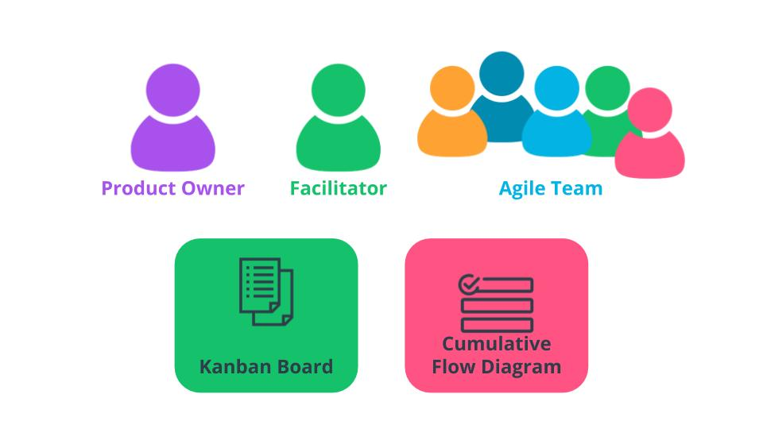

Kanban Roles and Artifacts

### New Terms

* **Cumulative Flow Diagram**: A diagram that shows the total amount of WIP and how quickly projects are being completed
* **Flow**: How work items in a process move through the various stages of development
* **Kanban Board**: A visual representation of the Agile team's work at various stages with a separate column for each stage
* **Kanban**: A lightweight Agile Framework that has its roots in Lean Principles
* **Lean Development**: A process to eliminate Muda by leveraging innovative solutions to reduce cycle time and cost

### Additional Resources

* [**Agile Alliance: Kanban(opens in a new tab)**](https://www.agilealliance.org/glossary/kanban/): Additional details on the Kanban Framework.
* [**Kanban at Blizzard Sport(opens in a new tab)**](https://prod-kanbanuniversity-backend-store.s3-us-west-2.amazonaws.com/case-studies/Blizzard-dist96.pdf): Blizzard Sports' case study shows the value of Kanban and its lightweight yet effective approach to delivering value.